Lab Assignment No: 01

Problem statement: Design static web page to demonstrate the use of different HTML tags.

NAME: Vivek Vikram Pundkar ROLLNO: 77

CLASS: C                    BRANCH: ENTC                        BATCH: 2

DATE OF PERFORMANCE: 07-09-2021

Code:

<!--- design static web page to demonstrate use of different html tags --->

<html>

    <head>

        <title>

            Exp. 1

        </title>

    </head>

    <body style="background-color:aliceblue;">

        <h1 style="background-color:orangered; text-align: center;" >We</h1>

        <h1 style="background-color: white; text-align: center; color: blue;">are</h1>

        <h1 style="background-color: green; text-align: center;">Indians</h1>

        <hr>

        Date to keep in minds!!

        <p> <abbr title="National Youth Day " > 12th Jan</abbr> <abbr title="Republic Day of India" >26th Jan</abbr></p>

        <p> </p>

        <p> <abbr title="International Women’s Day" >8 March</abbr> <abbr title="   Pi Day" > 14 March </abbr></p>

        <p> </p>

        <p> <abbr title="   National Doctor’s day" >1 July</abbr></p>

        <p> <abbr title="   International Friendship Day" >2 August</abbr> <abbr title="    Independence Day of India" >15 August</abbr></p>

        <p> </p>

        <p> <abbr title="Forgiveness day" >5 September</abbr> <abbr title="Engineer’s day in India" >15 September</abbr></p>

        <p> </p>

        <p> <abbr title="   World Teacher’s day" >5 October</abbr> <abbr title="    Indian Air Force Day" >8 October</abbr></p>

        <p></p>

        <p><abbr title="    Kisan Divas " >23 December</abbr></p>

        <hr>

        Country needs you!!

        <br>

        <p> <a href="https://joinindianarmy.nic.in/"> Join Army</a></p>

        <p><a href="https://www.joinindiannavy.gov.in/"> Join Navy</a></p>

        <p><a href="http://careerairforce.nic.in/"> Join Air</a></p>

        <hr>

        <h5 style="text-align: right;"><a href="Untitled-1.html">Contact us</a></h5>

    </body>

</html>

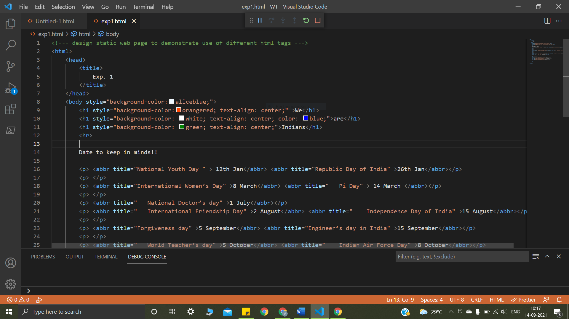

<html>

<head>

    <style>

    </style>

    <title>

       da da da da da its

    </title>

</head>

<body>

    <p>y nada mas</p>

    <div class="divi">

        <h1 >jojo</h1>

    </div>

    <div>

        <h4>rabbit</h4>

    </div>

    <a href="https:google.com"> play game</a>

<p>hella beredar</p>

<hr>

<br>

<br>

//Logical tag

<p>the sun mostly red <i>not</i> <strong> w T H </strong> it </p>

<p><mark>mumbai</mark></p>

<p> <abbr title="World Health Oranization" >WHO</abbr> was founded on 1948</p>

<address>

    Vivek Pundkar,<br>

    Vikas Nagar Akot <a href="vivek.pundkar@vit.edu"> 444101 </a> <br>

    Taq. Akot <br>

    Dis. Akola <br>

    state Maharastra <br>

</address>

</body>

</html>

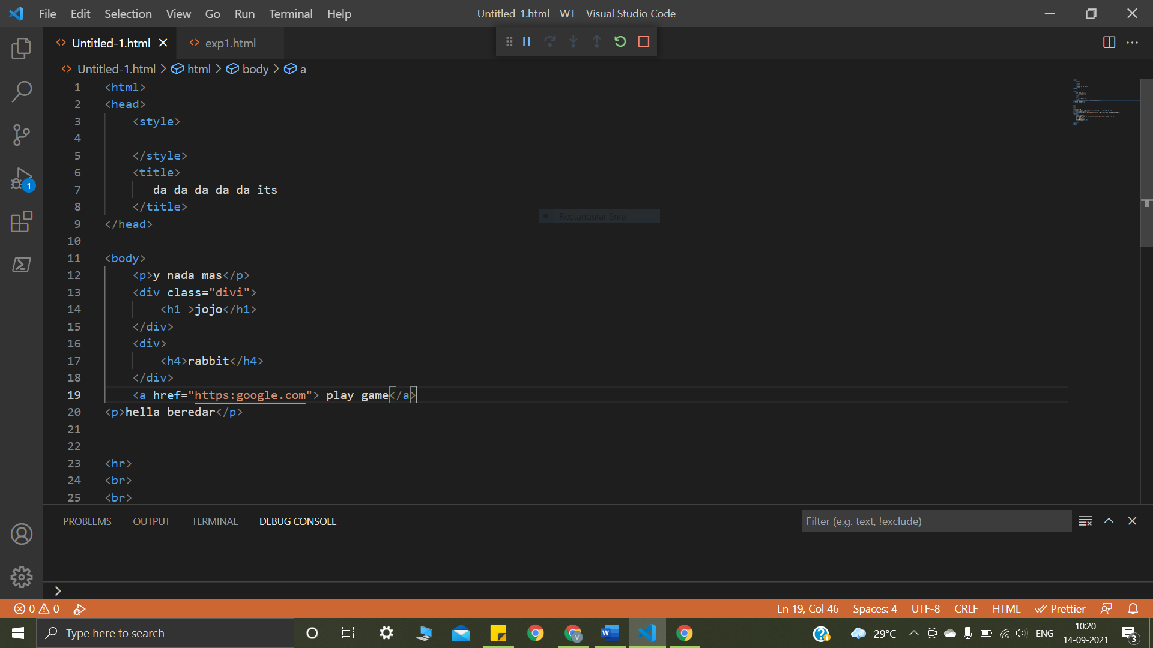

Output:

